Stage 4 ★★
Mixed Selection 1

- Pieces of eight
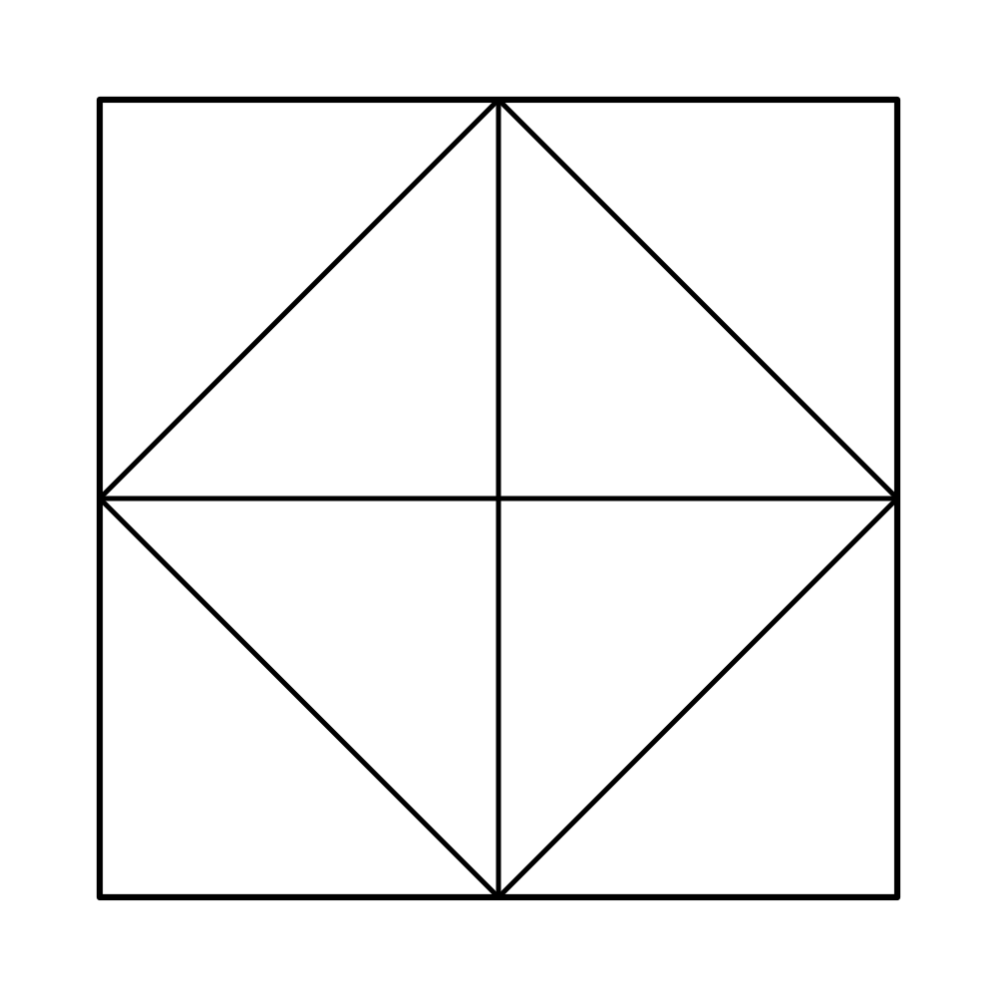
A square is divided into eight congruent triangles, as shown.
Two of these triangles are selected at random and shaded black.
What is the probability that the resulting figure has at least one axis of symmetry?

- Two girls
There are 10 girls in a mixed class.
If two pupils from the class are selected at random, then the probability that both are girls is 0.15.
How many boys are in the class?
- Swapping sweets
Kate and Anna each have a bag that contains a red sweet, a blue sweet, a green sweet and a yellow sweet.
Without looking, Kate takes a sweet out of her bag and puts it into Anna’s bag. Then, without looking, Anna takes a sweet from her bag and puts it into Kate’s bag.
What is the probability that after this, each bag contains a red sweet, a blue sweet, a green sweet and a yellow sweet?
- XOXOXO
3 tiles with the letter X on them and 3 tiles with the letter O on them are placed in a row. The order is chosen at random. What is the probability that no two adjacent tiles have the same letter on them?

